Jana Small Finance Bank Ltd.

PD Sheet – Salaried
Name of the Applicant  with DOB | Mr. R Abhishek (Application No: 102760000000833) 26/09/1997
Name of the Spouse with  DOB | Mrs. Aruna Not Provided
  Does the Spouse Work  If yes then  give brief | No  Not Applicable
Qualificatio  n | Graduation
Employer Name & Address | Avineon India Private Limited.  International tech Park, Opposite ITC Kohinoor, Madhapur Hyderabad
PD Place | International tech Park, gate No-5 , Madhapur
Designation | Trainee Associate-GIS
Current Monthly  Salary (Net) | Rs.22,880/-
No of yrs in present employmen  t | 2.3 Years approx.
No of  people in family |  | Name |  | Relation  with Applicant |  | Age (Yrs) | Qualification |  | Occupation |  | Income  per month (approx.) |  | Dependent
 |  | Mr. R  Abhisek |  | Self |  | 27 | Graduate |  | Job |  | Rs.22,000/- |  | Independent
 |  | Mrs. R  Aruna |  | Mother |  | 53 | Below 10th |  | None |  | 0 |  | Dependent
No of non-  earning members /  dependants | 01
Residence |  | Ownership | Area (in sq. ft) |  | Purchase Year / Rent Agreement Period |  |  | Purchase Cost / Rent per month | Current Market Value / Security  Deposit | Owner / Landlord (Relation with  borrower) |  | Tenant |  | Mortgaged
 |  | Rented | Not  Provided |  | Not  Provided |  |  | Rs.5,600/- | Not  Applicable | Not  Applicable |  | Not  Applicable |  | No
Applicant’s Job Profile | Mr. R Abhishek (Age-28 years) is working as a Trainee Associate-GIS in Geospatial  services department in Avineon India Private Limited since 2023. His salary transactions are 100% bank basis.

About the Company | Avineon India Pvt. Ltd., a subsidiary of Avineon, Inc., specializes in engineering, geospatial, and IT services and products that optimize data visualization, usability,  and effectiveness for government and commercial customers.
Previous  Employmen t | Not Applicable
Spouse’s Job Profile (if Spouse    working) | Not Applicable
Net Worth (Car / Property / Investments etc.) |  | Address |  |  |  |  |  | Area (in  sq.  ft) |  | Purchase Cost (in Lakhs) |  |  | Purchase Year |  | Market Value (in  Lakhs) |  | Owner Name |  | Mortgaged
 |  | Any Liquid, Moveable & Monetary items  such as Cash, Gold, FD, RD, Mutual Fund Holdings, Shares, Bonds, Securities - |  |  |  |  |  |  |  |  |  |  | Not Provided
 |  | Life Insurance, Mediclaim, Property/Asset  Insurance (Premium & Sum Assured) - |  |  |  |  |  |  |  |  |  |  | Not Provided
 |  | Capital invested in any business, Loans &  Advances given - |  |  |  |  |  |  |  |  |  |  | Not Provided
 |  | Car, Bike and any other vehicle (Company  Name and Model) - |  |  |  |  |  |  |  |  |  |  | Not Provided
 | Note: Amounts mentioned above are approx.
Loan Details |  | Nam e of Bank  / NBF  C | Type of Loan |  | Sanctione d Amount (in Lakhs) |  |  |  | O/S Balance (in Lakhs) |  |  | EMI (in Rs.) |  |  | Tenure (months) |  |  | Month on Books (MOB) |  | EMI Paid Bank | Secured Against which Asset
 |  | None | Not  Applicabl e |  | Not  Applicabl e |  |  |  | Not  Applicabl e |  |  | Not  Applicabl e |  |  | Not  Applicabl e |  |  | Not  Applicabl e |  | Not  Applicabl e | Not  Applicabl e
 | Note: Amounts mentioned above are approx.
Existing Relationshi p with Jana Small Finance  Bank Ltd. | Not Provided
Banking  Habits |  | Bank Name |  |  |  | Branch Name |  |  |  |  |  |  | Account Type |  |  |  |  | Open Since (Year)
 |  | ICICI Bank |  |  |  | Madhapur |  |  |  |  |  |  | Savings A/C |  |  |  |  | Not Provided
Credit Card  Details | No Credit Cards
Loan Amount Loan  Purpose | Rs.14 Lakhs approx. Apartment Flat Purchase
Security Offered | Address:  Apartment Flat Flat No-3302, Janapriya Avenue, Kothapet, Dilsukhnagar
 |  | Area (in  sq. ft) |  | Agreement  Value (in |  |  | Actual  Purchase |  |  |  | Market  Value (in |  |  | OCR (in  Lakhs) |  | OCR paid  till date |  |  | OCR  Source

 |  |  | Lakhs) |  | Cost (in  Lakhs) |  |  | Lakhs) |  |  |  | (in Lakhs)
 |  | 605 Sq fts | Not  Provided |  | 16 |  |  | 16 |  | Not  Applicable |  | Not  Applicable |  |  | Not  Applicable
 | Note: Amounts mentioned above are approx.
Other  Income |  | Income |  |  |  | Details |  |  |  |  | Reference
 | Note: Amounts mentioned above are approx.
  Third Party Confirmatio n |  | Individual / Business  Name |  | Address |  | Contact No |  |  | Knowing Since |  | Feedback on Borrower |  |  | Feedback on Business
 |  | International tech Park, Gate No-5 Security  Persons |  | Madhapur |  | Not Provided |  |  | 02 Years Above |  | Positive |  |  | Positive
Documents
Verified
Document  Category | Document Name |  |  |  |  |  | Document Type |  |  |  |  |  | Remarks
KYC Documents | AADHAAR Card |  |  |  |  |  | Original |  |  |  |  |  | We Verify found Correctly
KYC Documents | PAN Card |  |  |  |  |  | Original |  |  |  |  |  | Applicant: BVSPA2326K  DOB: 26/09/1997
Income & Expense Records | Salary Slip |  |  |  |  |  | Scan Image |  |  |  |  |  | MAY 2025  Total Net Pay Rs.19,200/- JUNE 2025  Total Net Pay Rs.19,200/- July 2025  Total Net Pay Rs.22,800/-
Income & Expense Records | Bank Statements |  |  |  |  |  | Scan Image |  |  |  |  |  | ICICI Bank Account Statements Of 08/08/2024 To 07/08/2025  Total Credited Amount  Rs.6,08,793/-
Other  Documents | ID Card |  |  |  |  |  | Original |  |  |  |  |  | We Verify found Correctly
Major Observation s / Comments / Concerns during PD | Case Strengths:  - Initiated address is applicant working office premise and he was met at the banker initiated address.  - Applicant has provided KYC documents, 03 months’ pay slips and bank statements, company identity card, offer letter during the visit time  - TPC was confirmed with international tech park gate no-5, security persons.  - His salary transactions are 100% bank basis and we have seen his salary crediting in the provided bank statement.  Case Weaknesses:  - Applicant has provided all the details from outside of the office premise due to outers not allowed into the office.  - Applicant has not provided increment letter during the visit.
PD Status | Positive (Subject to above concerns)
Name of the  Agency Executive | Srinu Arjilli

Date &  Time of Visit | 13 Aug, 2025 At 11:55
Checked By | Nandesu Sapata

Site Coordinates: Latitude: 17.4339224, Longitude: 78.3847743

Site Images:
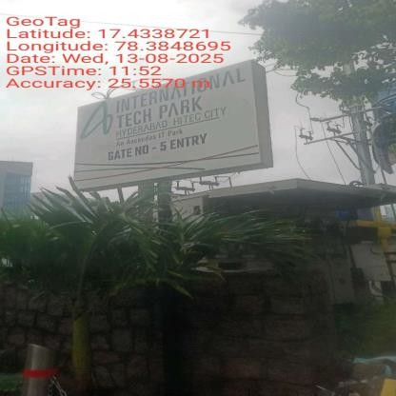 | 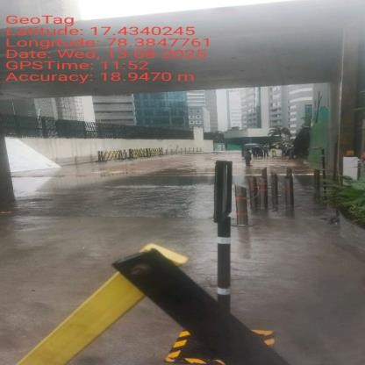 | 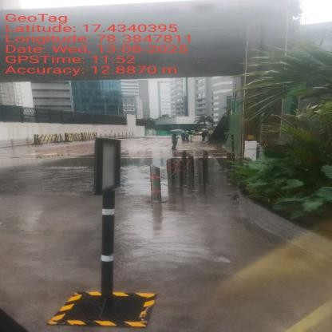
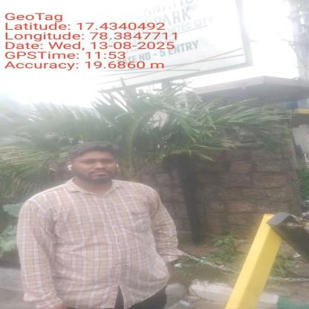 | 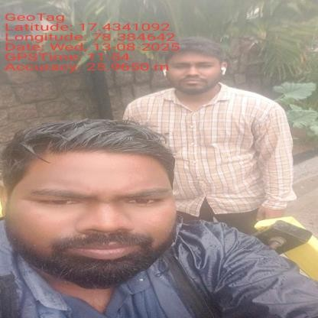 | 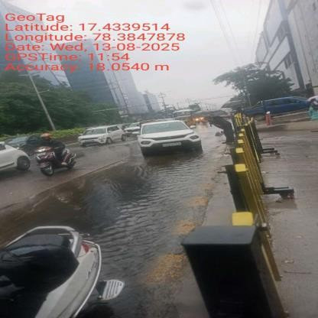
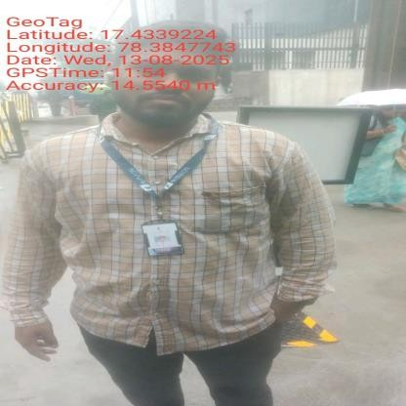 | 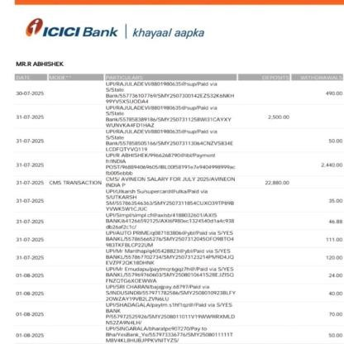 | 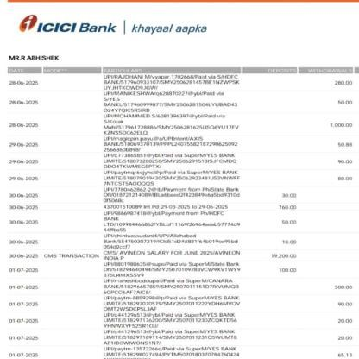

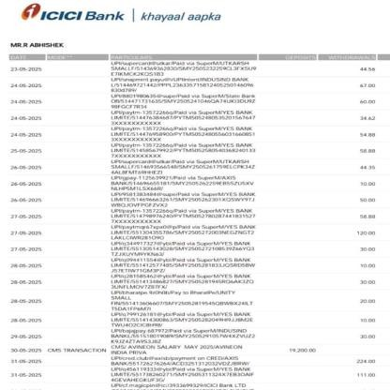 | 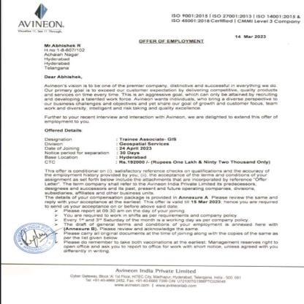 | 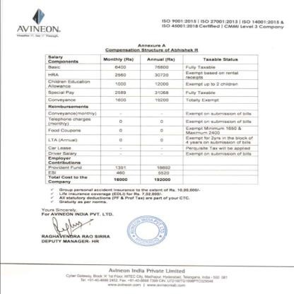
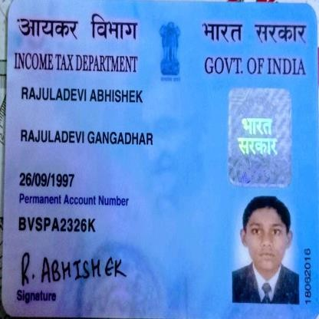 | 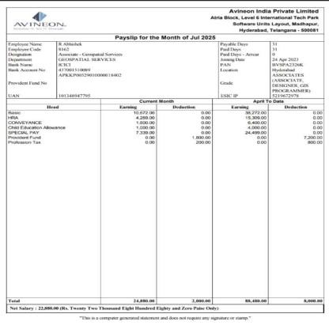 | 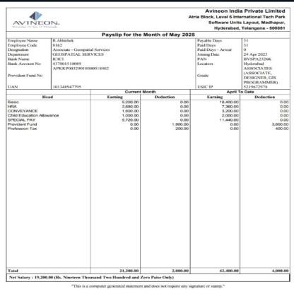
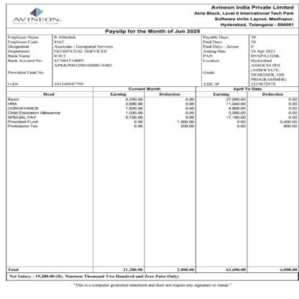 |  | 

Disclaimer:
This report (including any attachments) has been prepared on the basis of information provided by the person contacted. Jana Small Finance Bank Ltd. will be solely responsible for any actions taken on this report and any liabilities directly or indirectly accruing from such actions. Veeraraghavan & Co. will not be held liable in any case.


